Module 5: Critical Thinking Assignment

Nathan Rogers
Colorado State University Global
Course Code: CSC505
Dr. Luis Gonzalez
03/16/2025

Assignment
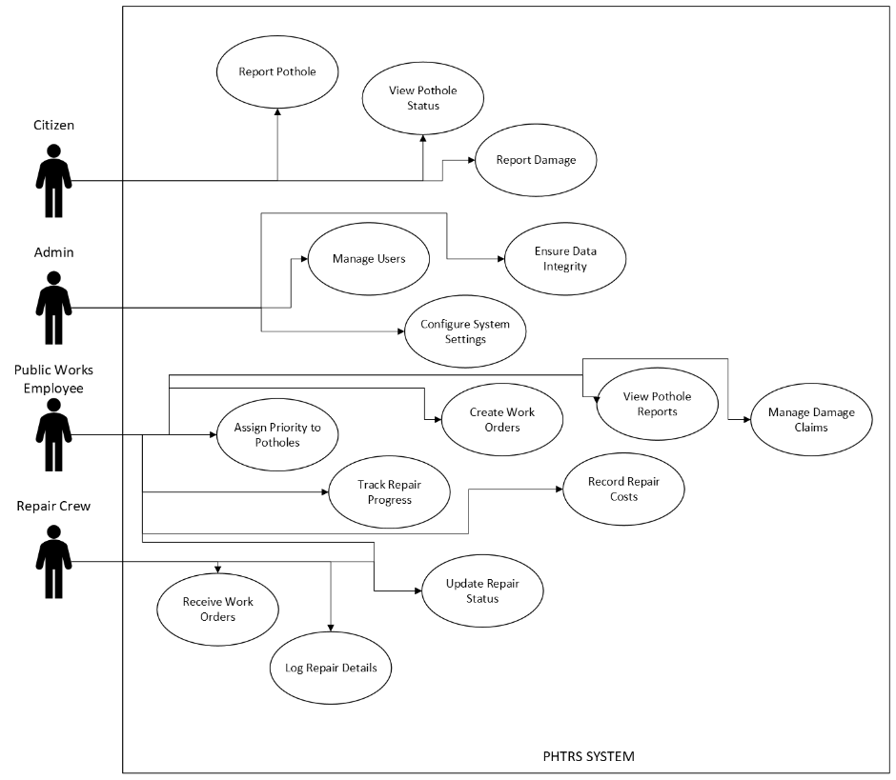
The department of public works for a large city has decided to develop a web-based pothole tracking and repair system (PHTRS). Draw a UML use case diagram for a PHTRS system. You'll have to make a number of assumptions about the manner in which a user interacts with this system. Use Python to write a script that will print out the different actors and use cases and a brief description of your diagram.

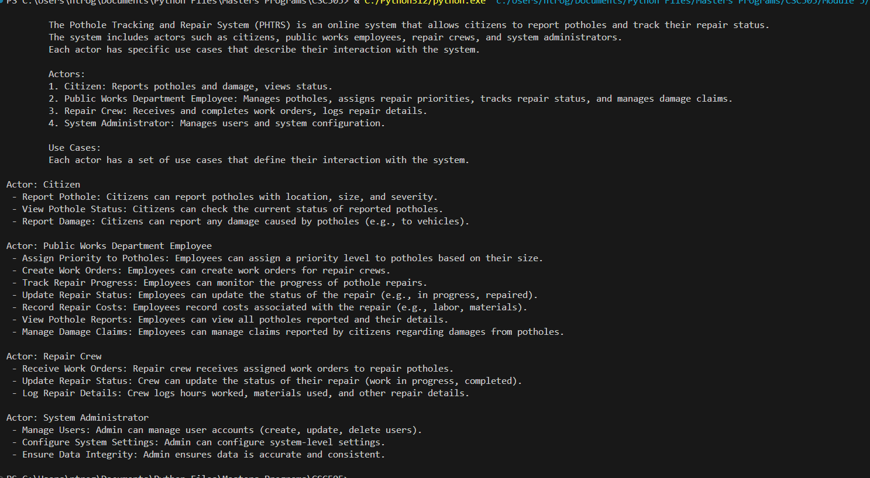

The above script output was achieved by utilizing a class structure called ‘PHTRS’ and each actor being initialized with a list of strings that aligns with describing the UML diagram. A for-loop with some formatted string print statements relays the output as above. The implementation of the PHTRS class would allow us to expand this script in the future if further information is required. Future-proofing a script or application can help development efforts, save time, and cut down on costs.

System Design and Requirements
A system of this scale must have pre-defined requirements. These requirements should include consideration for scalability, data security and ease of use. Let’s start with the UI and general system requirements. This is a web-based system which means a UI/UX engineer is needed to develop and test and consider the best programming languages and practices to use when designing this interface. There must be some kind of SQL or relational database/data storage that can be queried and returned to the user interface for use by the various users as described in the diagram above. Calculations and priority sorting are being used to sort the potholes based on size and location. This means we can use a docker pythonic backend to keep the code simple and easy to integrate into the front-end using http requests.
In terms of required hardware, a server rack that can run the web server, security protocols and SQL/relational database server is going to be needed unless the website hosting will be given to services such as Wix or GoDaddy. Using website hosting services would alleviate the difficulty with hosting the services ourselves but would limit our possibility for custom scripts and use cases outside the website hosting capabilities.
Data integrity and security are going to be huge priorities as user information such as names, addresses and other personal information will be stored in this system. A networking and security engineer will be needed to discuss and handle this.
“It is always a good idea to get stakeholders involved. One of the best ways to do this is to have each stakeholder write use cases that describe how the software will be used.” (Pressman & Maxim, n.d.). Getting stakeholder input can help speed up the development of a website and help alleviate the burden of development on the engineers.

System Use Case
Let’s look at a system use case scenario:
Primary Actors: User, PHTRS system, administrator, work employee, repair crew
Goal In Context: Login to PHTRS portal to log a pothole location.
Preconditions:
- Authentication servers are working normally
- Website is up and functioning normally
- User is not having issues with login prior to trying to log in.
Trigger: User clicks the login button on the website
Scenario:
- User enters their credentials into the username and password fields
- User clicks login
- User enters their two-factor authentication details and finishes the login process
- User clicks on “Log Pothole”
- User enters the location of the pothole, size on a scale from 1 – 10, district and repair priority.
- User clicks on “Report Damage”
- User enters their name, address, phone number, and dollar amount of damage.
- Admin verifies the correctness and integrity of data (no missing data, data is complete)
- Public Works employee will create a work order and assign the pothole repair a priority
- The repair crew is assigned to the work order
- The repair crew fixes the pothole and fills out the information in the portal
- Work order is marked complete and pothole is marked as fixed in the web portal
- Public Works employee completes the citizens (user) damage claim
Exceptions:
- The wrong address is inserted into the pothole logging entry
- The wrong address is inserted into the damage report from the user
- A work order fails to get created and no repair crew is assigned
- Data gets corrupted in transit and no log is created
- Data is accidentally deleted, and no repair order is created
- Repair crew mark the wrong pothole as fixed
- Log is accidentally altered, and data get changed, resulting in the wrong pothole being fixed
- Network error to where the log doesn’t get properly submitted into the system
- The relational database could be corrupted/maliciously attacked which would prevent any new logs from being created and people logging in to see their information and logs.
Priority: Essential, must be implemented
When Available: 24/7 for users to access the website
Frequency of use: Can be used several times a day by many people or not at all. This really depends on the traffic of the website
Channel to actor: Internet browser
Secondary actors: Secure Network, hosting service/server, ISP (Internet service provider)
Channels to secondary actors: Internet access

Data Security
When referencing the above user diagram, we can see that the user will be responsible for logging damages that resulted from a pothole. This information will include the users’ name, address, phone number, type of damage, and what the dollar amount of the damage was. To prevent data breaches, end-to-end data encryption will need to be used here between the UI and the relational database for long term storage. The network, server and relational database file will all need to be 256-bit encrypted to prevent data breaches but also prevent access to that data if the files are retrieved forcefully.
As an added layer of defense, user authentication through a password protected login and two factor authentication can also help prevent data breaches and unauthorized access to this data. Different layers of authentication may be used here to allow certain privileges over others such as admin privileges, employee privileges, and repair crew privileges. Ensuring data security and preventing data breaches will only help contribute positively to the user experience, satisfaction and trust.
Performance and Reliability
Since this website will be available 24/7 to the entire population of a metropolitan area, this system will have to be equipped to handle large volumes of people trying to access the system at one time. The system should be designed to scale up as more users join to report potholes around the city. The website should be able to maintain the speed of changing and loading pages even under heavy load from many users interacting with it at one time. “In today’s fast-paced digital environment, slow page load times can result in decreased user satisfaction” (Jehanne, 2023). In the event of a power failure, system failure or malicious attack it is also important to keep offline backups to restore the system. This will help with mitigating any lost data that might occur during these events.
Efficiency
With this new website, the process should be more efficient and more streamlined for getting damaging potholes fixed within the city. Repair crews and Public Works employees will have an easier time directing, working on high-risk potholes, and reporting back to the public on which ones were fixed. Also, being able to direct repair crews more efficiently will help the productivity and work ethic amongst the repair crews. Having quick response time reporting back to the public will help everyone’s quality of life and public trust within the community.

References
Pressman, R. S., & Maxim, B. R. (2020). Software engineering: A practitioner’s approach. McGraw-Hill Education.
Jehanne, M. (2023, October 7). Website experience: 10 key strategies for user satisfaction. Content Square. https://contentsquare.com/blog/website-experience-2/
Team, W. (2024, October 2). Website design questionnaires: 7 essentials things to ask your clients | Webflow blog. https://webflow.com/blog/questionnaire-for-website-design?utm_source=google&utm_medium=search&utm_campaign=SS-GoogleSearch-Nonbrand-DynamicSearchAds-US&utm_term=dsa-45211625058___491754501325__&gad_source=1&gclid=Cj0KCQjw7dm-BhCoARIsALFk4v-pXKzBzLixhG-1J-GNSnsGII2M5MbG6pBz09SCNPQAGbPQ4J-_sgEaApo_EALw_wcB

